Best practices about  
how SMEs utilize AI and Green practices.

**BEST PRACTICES**

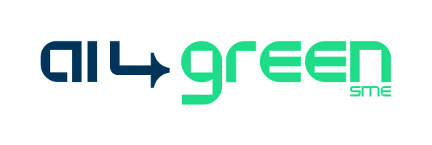

**Transforming Tomorrow, Today**

**Sector:** Technology / Sustainability / Water Management  
**Area of Impact**: Water / Climate Resilience **Location:** Greece  
[Eco Wave Dynamis](https://ecowavedynamis.com/)

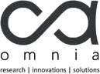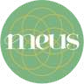

AI4GreenSME is a collaborative project funded by the European Union. Our consortium of partners brings together expertise in AI, sustainability, and SME development. (NOV 23 - OCT 24)

2023-1-ES01-KA220-VET-000150941

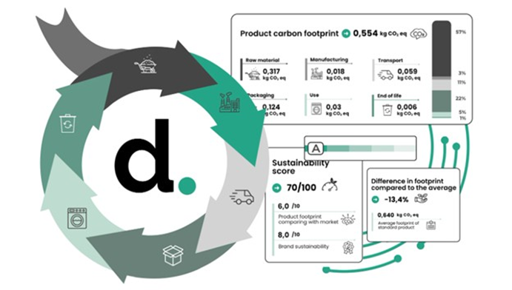

The project introduces a data-driven, ML-based water management tool for small-scale reservoirs. Unlike traditional manual monitoring, it automates forecasting and integrates multi-source data for more accurate and timely insights.

Eco Wave Dynamis has developed an AI Solution for Flood and Water Lever Forecasting, designed to support sustainable water management in Ikaria Island, Greece. The solution leverages **machine learning (ML) models** trained on historical sensor data from the reservoir and weather forecasts to predict surface water levels over multiple time horizons. The solution was developed by [SmartAttica EDIH](https://www.smartattica.eu/).

By integrating multiple data sources and providing forecasts through an API service, the system helps local water authorities enhance decision-making, optimize resource allocation, and improve resilience against climate variability.

**Objectives**

**Environmental:**

* Support sustainable reservoir management and water conservation.
* Prevent water shortages by enabling proactive planning and allocation.

**Social/Market:**

* Empower local authorities and communities with reliable data-driven insights.
* Strengthen resilience of island communities against climate-related challenges.

**Technological:**

* Develop and deploy ML-based forecasting models for water level prediction.
* Provide a modular API for CRUD operations and forecast access.

I

AI Solutions for Flood and Water Level Forecasting

**Outcomes and Impact**

* Designed an integrated architecture combining sensor data, weather data, and ML-based forecasting.
* Developed functional specifications and APIs to enable seamless data storage, retrieval, and forecast generation.
* Strengthened decision-making capacity for water resource managers on Ikaria Island.
* Demonstrated potential replicability in other reservoir and water management systems across Europe.
* equivalent emissions saved through interventions, purus lectus malesuada libero, sit amet commodo magna eros quis urna.

**• Significant reductions in cost and time for carbon footprint measurement when compared to traditional consultancy approaches; this enables smaller companies to access environmental impact data**

**Innovation Level**



**Evidence of Effectiveness**

* Functional specifications and system architecture completed.
* Baseline ML models trained and tested for forecasting reliability.

**Scalability and Replicability**

**Activities and Approach**

* Data Collection → Historical and real-time reservoir sensor data + weather forecasts.
* Database Design → Storage and management of sensor, weather, and forecast data.
* Model Training & Deployment → Baseline model development, selection of best-performing model, deployment for live forecasting.
* Forecasting API → Endpoints for data ingestion, updates, deletions, forecast generation, and storage.
* System Integration → Documentation and user guides for operational use by water managers.pulvinar ultricies, purus lectus malesuada libero, sit amet commodo magna eros quis urna.

**• Significant reductions in cost and time for carbon footprint measurement when compared to traditional consultancy approaches; this enables smaller companies to access environmental impact data**

The architecture is modular and API-driven, making it adaptable to other reservoirs and water bodies.

Can be integrated with broader water management frameworks and smart city infrastructures.

• Replicable across regions with similar data availability (sensors + weather forecasts).

and certifications support broader adoption.adipiscing elit. Maecenas porttitor congue

**Alignment with International Standards**

* Supports UN SDGs: SDG 6 (Clean Water and Sanitation); SDG 11 (Sustainable Cities and Communities); SDG 13 (Climate Action)
* Aligns with EU climate adaptation strategies and digital innovation in water management.

**Partnerships / collaborations**

* The project was developed by [SmartAttica EDIH](https://www.smartattica.eu/).



**Challenges**

* Data quality and consistency from reservoir sensors.
* Integration of weather data with reservoir data.
* Limited digital infrastructure for local water authorities.

**Lessons Learned**

* Data integration is key: combining weather and sensor inputs enhances reliability.
* APIs facilitate scalability: modular design supports broader adoption.