Best practices about  
how SMEs utilize AI and Green practices.

**BEST PRACTICES**

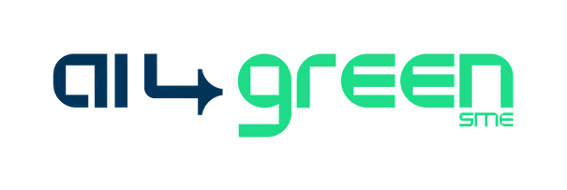

**Transforming Tomorrow, Today**

**Sector:** Construction / Sustainability / Technology  
**Area of Impact**: Circular Economy / Decarbonization in Construction **Location:** Greece  
[**UrbanCamel**](https://theurbancamel.com/)



AI4GreenSME is a collaborative project funded by the European Union. Our consortium of partners brings together expertise in AI, sustainability, and SME development. (NOV 23 - OCT 24)

2023-1-ES01-KA220-VET-000150941

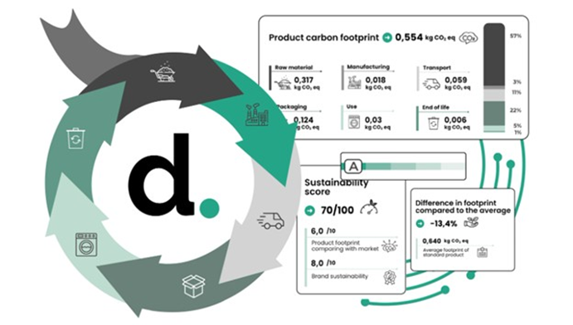

Urban Camel has developed an **AI-powered chatbot** hosted on its website to provide **specialized sustainability guidance** to architectural offices, construction companies, and other sector stakeholders.

The chatbot integrates a **Retrieval-Augmented Generation (RAG) pipeline**, advanced search and retrieval capabilities, and a dynamic knowledge base. It is designed to accelerate the adoption of sustainable construction practices, promote material reuse, and offer actionable advice on decarbonization, training, and certification.

The solution was developed by [SmartAttica EDIH](https://www.smartattica.eu/).

By integrating multiple data sources and providing forecasts through an API service, the system helps local water authorities enhance decision-making, optimize resource allocation, and improve resilience against climate variability.

**Objectives**

Environmental:

* Promote the reuse of construction materials and circular economy principles.
* Reduce carbon emissions from construction by encouraging sustainable material selection and waste reduction.

Social/Market:

* Support construction professionals with on-demand sustainability advice.
* Provide access to certified material databases and training opportunities.
* Strengthen transparency and regulatory compliance in the sector.

Technological:

* Develop a scalable, AI-based chatbot with RAG integration and multimodal knowledge base.
* Enable real-time, reliable, and secure interactions with role-based access.
* Provide future-ready features such as supplier recommendations and certification services.
* Provide a modular API for CRUD operations and forecast access.

I

AI-Powered Knowledge Platform for Circular Economy in Construction

**Outcomes and Impact**

* A prototype chatbot capable of providing context-specific, AI-generated guidance on sustainable construction practices.
* Increased awareness and adoption of low-carbon materials and methods within the sector.
* Enhanced accessibility of certified ecological materials and training resources.
* Potential for expansion into a certification service, increasing compliance with green construction laws and standards.

**Innovation Level**

The chatbot brings AI-driven guidance into the construction sector by combining domain-specific datasets with Retrieval-Augmented Generation pipelines for contextualized advice. Its integration of multimodal data sources creates a comprehensive, adaptable knowledge base, while real-time chat with transparent citations ensures trust and usability.



**Evidence of Effectiveness**

* Functional specifications and architecture completed.
* Expected to deliver measurable improvements in knowledge access and sustainability adoption for construction SMEs.

**Activities and Approach**

* Data & Model Development: Curating sector-specific datasets, preprocessing data, and training/fine-tuning ML models within a RAG pipeline.
* System Integration: Building secure APIs, enabling real-time chat with citations, and connecting to a multimodal knowledge base.
* Deployment & Customization: Containerizing the solution, ensuring scalability, and adapting the chatbot to communication needs.

**Scalability and Replicability**

* Modular architecture with APIs and containerized deployment enables easy scaling.
* Can be adapted to multiple languages and regional regulations.
* Future-ready for expansion into training, supplier databases, and certification services.
* Replicable for other industries seeking AI-driven sustainability knowledge systems.
* Replicable across regions with similar data availability (sensors + weather forecasts).
* and certifications support broader adoption.adipiscing elit. Maecenas porttitor congue

**Alignment with International Standards**

* UN SDGs Supported: SDG 9 (Industry, Innovation, and Infrastructure); SDG 11 (Sustainable Cities and Communities); SDG 12 (Responsible Consumption and Production); SDG 13 (Climate Action)
* Potential alignment with EU Taxonomy for Sustainable Activities and Circular Economy Action Plan.

**Partnerships / collaborations**

* The solution was developed by [SmartAttica EDIH](https://www.smartattica.eu/).



**Challenges**

**Lessons Learned**

* Ensuring data quality of curated datasets.
* Integrating multimodal data sources into a single knowledge base.
* Building user trust in AI-generated advice within a traditional industry.

Sector-specific tailoring matters: a general chatbot lacks the precision construction professionals require.

Transparency drives trust: citations and references are essential for adoption.